Theorem 6.1 A parallelogram with two consecutive congruent sides is a rhombus.
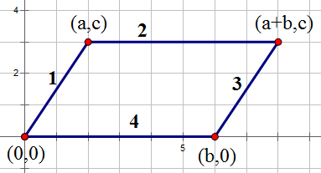

Given a parallelogram such that side 1 is congruent to side 4 we want to show that the parallelogram is a rhombus (parallelogram with all four sides equal). First find all of the lengths of the side.
$$distance1=\sqrt{{\left(a-0\right)}^{2}+{\left(c-0\right)}^{2}}→\sqrt{a^{2}+c^{2}}$$
$$distance2=\sqrt{{\left(a+b-a\right)}^{2}+{\left(c-c\right)}^{2}}→\sqrt{b^{2}}→b$$
$$distance3=\sqrt{{\left(a+b-b\right)}^{2}+{\left(c-0\right)}^{2}}→\sqrt{a^{2}+c^{2}}$$
$$distance4=\sqrt{{\left(b-0\right)}^{2}+{\left(0-0\right)}^{2}}→\sqrt{b^{2}}→b$$
Notice that no matter which two consecutive sides you pick to be congruent you will always get that $\sqrt{a^{2}+c^{2}}=b$. Now notice that side 1 is congruent to side 3 and side 2 is congruent to side 4. Or that $\sqrt{a^{2}+c^{2}}=\sqrt{a^{2}+c^{2}}$and $b=b$.Thus, since $b=\sqrt{a^{2}+c^{2}}$ all four sides are congruent.

Theorem 6.2 A parallelogram with congruent diagonals is a rectangle.
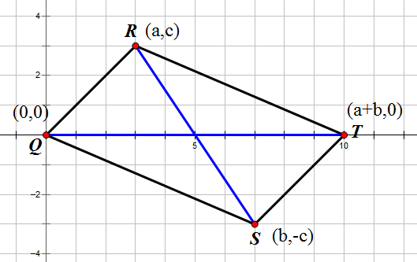

Given a parallelogram such that D1$≅$D2 we want to show that it is a rectangle, or that all consecutive sides are perpendicular. If the diagonals are congruent then
$$\sqrt{{\left(a-b\right)}^{2}+{\left(c+c\right)}^{2}}=\sqrt{{\left(a+b\right)}^{2}}$$
$${\left(a-b\right)}^{2}+{\left(2c\right)}^{2}={\left(a+b\right)}^{2}$$
$$a^{2}-2ab+b^{2}+4c^{2}=a^{2}+2ab+b^{2}$$
$$-2ab+4c^{2}=2ab$$
$$4c^{2}=4ab$$
$$c^{2}=ab$$
Now that we know $c^{2}=ab$ let’s check to see if consecutive sides are perpendicular. To check this we want to see if the slope of one is congruent to the others negative reciprocal of the other. First let’s check $\overline{QS} \text{and} \overline{QR}$.
$$\frac{-c}{b}=-\frac{a}{c} → \frac{c^{2}}{b}=a → \frac{ab}{b}=a → a=a$$
Thus we know $\overline{QS}\text{ is }\text{perpendicular}\overline{QR}$. Because this is a parallelagram theorem 5.7 tells us that $∠RQS≅∠RTS$. This means that $\overline{RT} \text{is perpendicular to }\overline{TS} \text{as well.}$ Now let’s look at $\overline{QS} \text{and} \overline{QR}$.
$$\frac{c}{a}=-\frac{b}{-c} → \frac{c^{2}}{a}=b → \frac{ab}{a}=b → b=b$$
Thus we know that $\overline{QS}\text{ is }\text{perpendicular}\overline{QR}$. And again by Theorem 5.7 we can see that $∠QRT≅∠TSQ$. This means that all consecutive lines are perpendicular and that a parallelogram with equal diagonals is a rectangle as desired.

Theorem 6.3 A rectangle with perpendicular diagonals is a square.
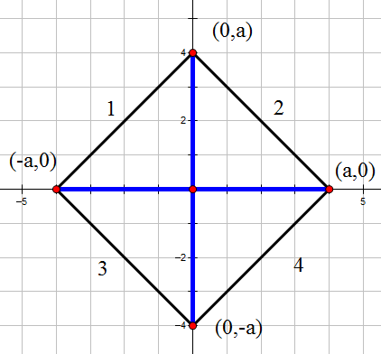

Given a rectangle with congruent diagonals we want to show that the rectangle is a square. From Theorem 5.8 we know that the diagonals Bisect each other. When combining this with Theorem 6.2 this means that the rectangle can be positioned like the above where each corner is the same distance from the center. Now we can see if all four sides equal.

$$distance1=\sqrt{{\left(0+a\right)}^{2}+{\left(a-0\right)}^{2}}→\sqrt{a^{2}+a^{2}}$$
$$distance2=\sqrt{{\left(0-a\right)}^{2}+{\left(a-0\right)}^{2}}→\sqrt{a^{2}+a^{2}}$$
$$distance3=\sqrt{{\left(-a-0\right)}^{2}+{\left(0+a\right)}^{2}}→\sqrt{a^{2}+a^{2}}$$
$$distance4=\sqrt{{\left(a-0\right)}^{2}+{\left(0+a\right)}^{2}}→\sqrt{a^{2}+a^{2}}$$

We can see that all four sides are congruent. Thus the rectangle is a square.

Theorem 6.4 A rhombus with one right angle is a square.

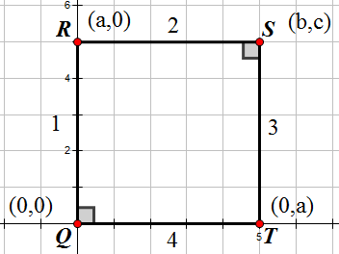

Given a rhombus with one right angle we want to show that it is a square. We know from Theorem 5.7 that ∠TQR≅∠RST. This means that the slope of side 2 is congruent to the negative reciprocal of the slope of side 3. Or…

$$\frac{b-0}{c-a}=-\frac{c-0}{b-a} → \frac{b}{c-a}=\frac{-c}{b-a} → b\left(b-a\right)=-c\left(c-a\right) → b^{2}-ab=-c^{2}+ac…$$
$$…→ b^{2}+c^{2}=ab+ac→\frac{b^{2}+c^{2}}{b+c}=a$$
The only way for this to be true is if both $b\text{ and }c \text{equal }a.$ Thus point S $=\left(a,a\right)$. Now let’s see if the slope of side 1 is congruent to the negative reciprocal of side 2.

$$\frac{0-0}{a-0}=-\frac{a-a}{a-0} → \frac{0}{a}=\frac{0}{a}$$
This means Side 1 is perpendicular to side 2 and from Theorem 5.7 we know its opposite angle is congruent. Thus ever consecutive angle of the rhombus is perpendicular and it is a square.

